Curriculum Vitae (C.V.)
- Personal data:
Name (Arabic) | إيناس ممدوح متولي
Name (English) | Enas Mamdouh Metwally
Department | Dermatology and venerology
College | Benha university for medicine
Academic degree | Assistant lecture
Office Address | Benha university
Mobile 1 | 01016796412
Home phone
Work phone
Fax
Email (university)
Email (alternative) | Enas.alakber@yahoo.com
Web site (if any)
Recent Photo (passport format) | 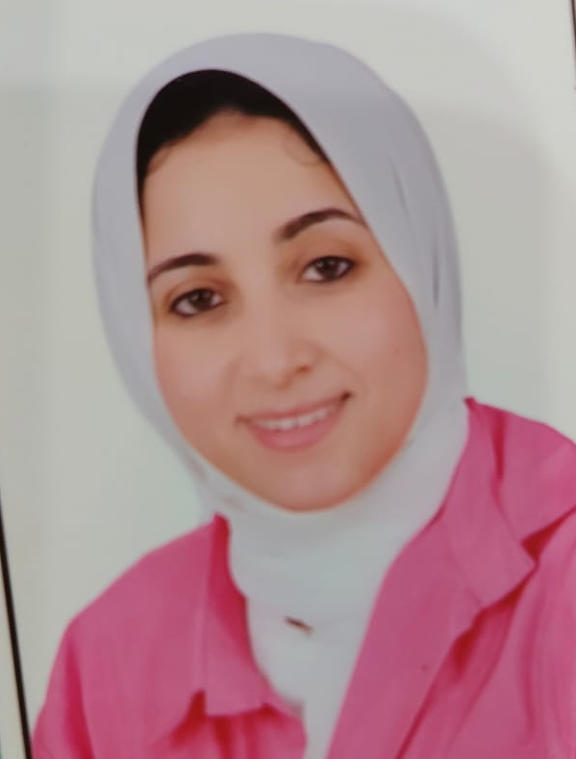
- Education:
2.A. Degree obtained;
Institution | Degree obtained | Year
 | Assistant lecturer | 2021

2.B. Specialty;
General specialty. | Dermatology , venereology and andrology department
Specific specialty.

2.C. Language skills (Excellent, Very Good, Good or Basic);
Language | Reading | Speaking | Writing
Arabic. | Good | Good | Good
English. | good | good | good
French.
Other (specify).

- Positions:
Tittle | Year | University/Institution
Assistant lecturer | 2025 | Benha university hospitals

- Cooperation with local and international entities having website:
( جامعة – مؤسسة - وزارة – مركز بحثي – عضو هيئة تدريس – باحث - شركة – مصنع – الخ)
Name of local and international entity | Website
- …..
- Membership of professional bodies (List):

- Membership of institute (List):

- Distinction and Awards (List):

- Academic:
Courses at under graduate level;
Cosmetics in dermatology | Clinical rounds;
infection | Clinical rounds
Courses at post graduate level;
Keratinization disorders | Clinical rounds;
eczema | Clinical rounds
- Areas of research:

- PhD/M.Sc Supervision:
Title | PhD/M.Sc | Year completed / in progress
Varicocele |  | 2021

- Grants for Projects:
Funding organization | Project title | Role | Year
- Committees:

- List of Publications:

14. Attended Workshops, Symposiums, and Conferences: "List name and year";

Name of Workshops, Symposiums, and Conferences | Year
Sharm derma 2024 | 2024

- Books published:

16. Positions:
 | Date | Organization | Country | Position
1
2
3

17. Activities in faculty/university/community service:
Name of Activity service | Year
- Teaching (Rounds and lectures).
- Clinical meeting.
- Making conferences.
- Medical Convoys.
- Workshops.
18. Consulting Experience (if any):

19. Additional information you would like to put on the website:

